Implementation of AXI protocol using Verilog

Theme Based Project
Submitted in partial fulfillment of the academic requirement for the award of the degree of

BACHELOR OF ENGINEERING
In

ELECTRONICS AND COMMUNICATION ENGINEERING

By

P.RAKESH | 1602-23-735-029
S.VISHNU VARDHAN REDDY | 1602-23-735-061
B.VISHWESHWARA ANAND | 1602-23-735-063



Department of Electronics and Communication Engineering Vasavi College of Engineering (Autonomous)
ACCREDITED BY NAAC WITH 'A++' GRADE
IBRAHIMBAGH, HYDERABAD-500031

2025-2026



Department of Electronics and Communication Engineering Vasavi College of Engineering (Autonomous)
ACCREDITED BY NAAC WITH 'A++' GRADE
IBRAHIMBAGH, HYDERABAD-500031

CERTIFICATE

This is to certify that the Mini Project-I titled “Implementation of AXI protocol using verilog “ submitted by
P.RAKESH 1602-23-735-029
S.VISHNU VARDHAN REDDY 1602-23-735-061
B.VISHWESHWARA ANAND 1602-23-735-063

Students of Electronics and Communication Engineering Department, Vasavi College of Engineering in partial fulfillment of the requirement for the award of the degree of Bachelor of Engineering in Electronics and Communication Engineering is a record of the Bonafide work carried out by them during the academic year 2025-2026. The result embodied in this Theme Based Project report has not been submitted to any other university or institute for the award of any degree

Head of the Department Internal Guide
Dr. E. Sreenivasa Rao E.C.E Department
Professor and HOD
E.C.E Department

DECLARATION

This is to state that the work presented in this thesis titled “Implementation of AXI protocol using verilog ” is a record of work done by us in the Department of Electronics and Communication Engineering, Vasavi College of Engineering, Hyderabad. No part of the thesis is copied from books/journals/internet and wherever the portion is taken, the same has been duly referred in the text. The report is based on the project work done entirely by us and not copied from any other source. I hereby declare that the matter embedded in this thesis has not been submitted by me in full or partial thereof for the award of any degree/diploma of any other institution or university previously.

Signature of the students

P.RAKESH | 1602-23-735-029
S.VISHNU VARDHAN REDDY | 1602-23-735-061
B.VISHWESHWARA ANAND | 1602-23-735-063

ACKNOWLEDGEMENTS

The satisfaction and euphoria that accompany the successful completion of any task would be incomplete without mentioning the people whose constant guidance and encouragement made it possible. We take pleasure in presenting before you our project, which is the result of a blend of both research and knowledge studied.
We record with pleasure our deep sense of gratitude to Dr. E. Sreenivasa Rao, Head of the Department, E.C.E., for his simulating guidance and profuse assistance we have received, which helped throughout the project.
We also thank our Theme Based Project coordinators, Dr. Srilakshmi Aouthu, Associate Professor, Department of ECE and Ms. K.R Deepthi, Assistant Professor, Department of ECE for their continuous guidance and valuable suggestions throughout our project.
Our sincere thanks to the Principal and Management, Vasavi College of Engineering, Hyderabad, for providing all the facilities for carrying out the project successfully.
Also, we acknowledge with thanks for the support extended by all the staff members and technical staff in shaping up our project. We are thankful to one and all who co-operated with us during the course of our project work.

P.RAKESH | 1602-23-735-029
S.VISHNU VARDHAN REDDY | 1602-23-735-061
B.VISHWESHWARA ANAND | 1602-23-735-063

Implementation of AXI protocol using verilog

Dr. A Srilakshmi¹ Associate Professor, Department of ECE Vasavi College of Engineering (A) Hyderabad, Telangana a.srilakshmi@staff.vce
.ac.in
K.R. Deepthi² Assistant Professor, Department of ECE Vasavi College of
Engineering (A), Hyderabad, Telangana r.deepthi@staff.vce.a c.in
P.Rakesh³
Department of ECE Vasavi College of Engineering (A) Hyderabad, Telangana rakesh.punganuru@gmail. com
S.Vishnu Vardhan⁴ Department of ECE Vasavi College of Engineering (A) Hyderabad, Telangana vishnuvardhan@
gmail.com
B.V.Anand⁵
Department of ECE Vasavi College of Engineering (A) Hyderabad, Telangana anandbussa2005@gmail.com

ABSTRACT:

This project presents the design and implementation of the Advanced eXtensible Interface (AXI) protocol using Verilog HDL for efficient on-chip communication in modern System-on-Chip (SoC) architectures. The proposed design aims to achieve high throughput, low latency, and reliable data transfer while maintaining scalability and modularity suitable for complex digital systems. The AXI protocol supports burst-based transactions, separate read and write channels, and out-of-order completion, making it well-suited for high-performance applications.
The implementation was carried out by modeling the AXI master and slave interfaces in Verilog, ensuring compliance with protocol specifications such as handshake mechanisms, address decoding, and data transfer sequencing. Design calculations and timing analysis were performed to validate throughput, latency, and resource utilization. Functional verification was conducted using simulation tools to evaluate correctness under various traffic scenarios, including single and burst transactions.
The target specifications included support for multiple outstanding transactions, efficient arbitration, and proper synchronization between channels. Simulation results demonstrated satisfactory performance in terms of bandwidth utilization, protocol compliance, and timing accuracy. The designed AXI protocol module can be effectively integrated into digital systems such as processors, memory controllers, and peripheral interfaces, thereby enabling robust and scalable communication infrastructure.
The overall design methodology and hardware description approach provide an efficient framework for implementing standard bus protocols in Verilog, ensuring compatibility and performance in advanced SoC designs.

.INTRODUCTION
On-chip communication protocols play a crucial role in modern digital systems, particularly in System-on-Chip (SoC) architectures where multiple processing units, memory blocks, and peripheral devices must exchange data efficiently. Among various bus protocols, the Advanced eXtensible Interface (AXI) protocol, defined as part of the ARM AMBA specification, has emerged as a widely adopted standard due to its high performance, scalability, and support for parallel transactions. AXI enables burst-based transfers, independent read and write channels, and out-of-order transaction completion, making it suitable for complex and high-speed SoC designs.
Traditional bus architectures often suffer from limited throughput and higher latency, which restrict their applicability in high-performance systems. AXI overcomes these limitations by providing separate address and data channels, handshake-based signaling, and flexible transaction ordering. This ensures improved bandwidth utilization and reduced communication bottlenecks.
In this project, the AXI protocol is implemented using Verilog Hardware Description Language (HDL). The design focuses on modeling AXI master and slave interfaces, incorporating essential features such as address decoding, data transfer sequencing, and handshake mechanisms. The implementation is verified through simulation to evaluate correctness under different traffic scenarios, including single transactions and burst transfers.
The important design parameters considered during the development of the AXI protocol include:
- Throughput
- Latency
- Bandwidth utilization
- Protocol compliance
- Resource efficiency
The implementation methodology provides a practical framework for understanding bus protocol design and verification in Verilog. By ensuring compliance with AXI specifications, the developed module can be effectively integrated into SoC environments for applications such as processors, memory controllers, and peripheral communication.

PROPOSED METHODOLOGY

I. PROPOSED METHODOLOGY
The proposed work focuses on the design and implementation of the AXI protocol using Verilog HDL. The methodology is structured to ensure compliance with protocol specifications while maintaining efficiency, modularity, and scalability for integration into System-on-Chip (SoC) environments. The complete design flow is carried out by considering important digital performance parameters such as throughput, latency, bandwidth utilization, protocol compliance, and resource efficiency.
The AXI protocol is implemented by modeling master and slave interfaces, each consisting of independent read and write channels. Handshake mechanisms are employed to synchronize transactions, while address decoding and data sequencing ensure correctness of communication. Functional verification is performed through simulation to validate the design under different traffic scenarios.
a) Selection of Design Specifications
Initially, the design specifications were selected based on SoC communication requirements. The important specifications considered in this project are:
- Throughput ≥ 1 Gbps
- Latency ≤ 10 cycles
- Support for burst transactions (up to 16 beats)
- Multiple outstanding transactions
- Separate read and write channels
- Protocol compliance with AMBA AXI4 standard
These parameters act as the foundation for Verilog module design and testbench development.

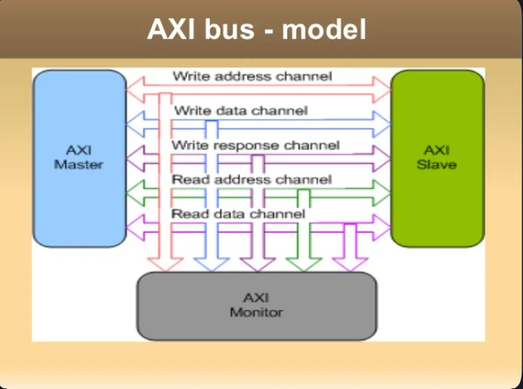
b) Selection of AXI Architecture
An AXI master-slave architecture was selected to model communication between processing units and memory/peripherals. The master initiates transactions by sending address and control signals, while the slave responds with data or acknowledgments.
The architecture includes:
- Read Address Channel
- Read Data Channel
- Write Address Channel
- Write Data Channel
- Write Response Channel
This separation of channels reduces contention and improves throughput.
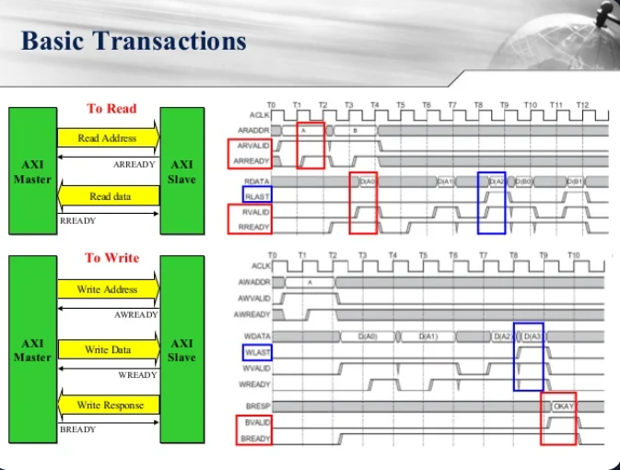
c) Implementation of Handshake Mechanism
Handshake signals such as VALID and READY were implemented to ensure synchronization between master and slave. Each channel uses these signals to confirm data transfer, thereby avoiding timing mismatches and ensuring reliable communication.
The Verilog design models these signals explicitly, with state machines controlling transaction flow.
d) Address Decoding and Data Sequencing
The slave interface was designed to decode incoming addresses and map them to appropriate memory locations. Data sequencing logic ensures correct ordering of burst transactions, even when multiple outstanding transactions are present.
e) Simulation and Verification
Functional verification was carried out using a Verilog testbench. Different traffic scenarios were applied, including single transfers, burst transfers, and concurrent read/write operations. Simulation results were analyzed to evaluate:
i.Protocol compliance
ii.Timing accuracy
iii.Bandwidth utilization
iv.Resource efficiency

f) Integration into SoC Environment
The designed AXI protocol module was tested for integration into a simplified SoC model, demonstrating compatibility with processors, memory controllers, and peripheral devices. This validates the scalability and robustness of the design.

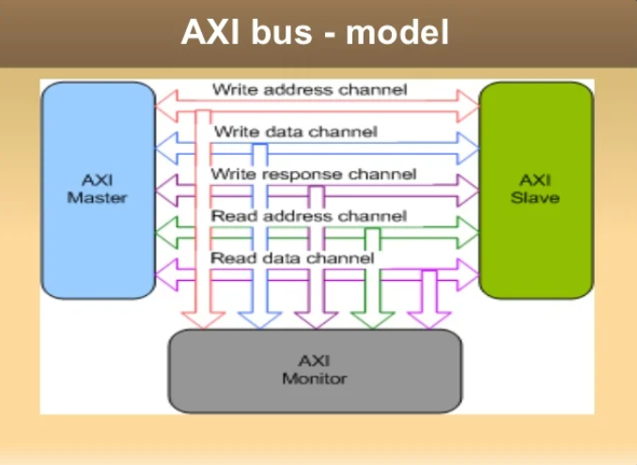

𝐶𝐶 ≥ 0.22𝐶𝐿

𝐶𝐿 = 2𝑝𝐹

    - Load Capacitance = 2 pF
    - Supply Voltage = 1.2 V

These parameters act as the foundation for transistor sizing and compensation capacitor design.
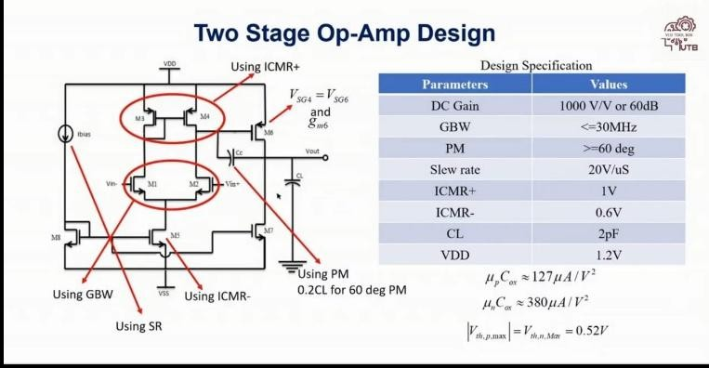

Fig. 1. Design specifications and architecture of the proposed two-stage CMOS operational amplifier.)
the compensation capacitor was selected as:
𝐶𝐶 = 800𝑓𝐹

This value provides sufficient phase margin greater than 60∘.

In multistage operational amplifiers, multiple poles are present due to parasitic capacitances associated with MOS transistors. These poles introduce additional phase shift, which can reduce the stability of the amplifier and may lead to oscillations. To overcome this problem, Miller compensation technique was employed in the proposed design. A compensation capacitor
𝐶𝐶 was connected between the output of the first stage and the input of the second stage to achieve pole splitting. Due to pole splitting, the dominant pole shifts toward lower frequency while the non-dominant pole shifts toward higher frequency, thereby improving phase margin and overall stability of the amplifier. [2], [3]
The effective Miller capacitance can be expressed as:
𝐶𝑒𝑓𝑓 = 𝐶𝐶(1 + 𝐴𝑣)

Selection of Two-Stage CMOS Op-Amp Architecture
A two-stage CMOS operational amplifier architecture was selected because a single-stage amplifier cannot provide sufficiently high gain for analog VLSI applications. The first stage acts as a differential amplifier which converts differential input voltage into current, while the second stage acts as a common source amplifier that increases overall voltage gain. [2]
The overall gain is given by:
𝐴𝑣 = 𝐴1 × 𝐴2
where:
    - 𝐴₁= gain of first stage
    - 𝐴₂= gain of second stage
    - Packet type
where:
    - 𝐶𝐶 is the compensation capacitor
    - 𝐴𝑣is the voltage gain of the amplifier stage
For stable operation of the proposed amplifier, the compensation capacitor was selected using the condition:
𝐶𝐶 ≥ 0.22𝐶𝐿
Using the load capacitance value of 2𝑝𝐹 , the compensation capacitor was chosen as 800𝑓𝐹, which provides phase margin greater than 60∘.

Slew Rate Based Bias Current Calculation
The tail current 𝐼₅was calculated using slew rate requirements. The relationship between slew rate and compensation capacitor is given by:

  - Data validity
  - Error detection signals

Design of Compensation Capacitor 𝑪𝑪

Using:
  - 𝑆𝑅 = 20𝑉/𝑚𝑢𝑠
  - 𝐶𝐶 = 800𝑓𝐹
𝑆𝑅 =
𝐼5

𝐶𝐶

To improve the stability of the operational amplifier, Miller compensation technique was used. A compensation capacitor
𝐶𝐶 was connected between the first and second stages to achieve pole splitting and improve phase margin. [3]
the bias current obtained was approximately:
𝐼₅ ≈ 20𝜇𝐴

This current was used for biasing the differential pair.

The slew rate of the operational amplifier determines the maximum rate at which the output voltage can change with time. It is one of the important large-signal performance parameters of an op-amp and mainly depends on the bias current and compensation capacitor used in the circuit. In the proposed design, the slew rate requirement was fixed at 20𝑉/𝜇𝑠. The tail current source transistor 𝑀₅ was designed based on this specification. [1]
The relationship between slew rate, bias current, and compensation capacitor is given by:
𝐼5
𝑆𝑅 =
𝐶𝐶
Rearranging the equation:
𝐼5 = 𝑆𝑅 × 𝐶𝐶
Substituting the design values:
  - 𝑆𝑅 = 20𝑉/𝜇𝑠
converting the differential input voltage into output current. The transconductance of the input pair directly affects the bandwidth and gain of the amplifier. [2]
The transconductance of the differential pair is related to the gain bandwidth product by:
𝑔𝑚1 = 2𝜋 × 𝐺𝐵𝑊 × 𝐶𝐶
Substituting the design values:
  - 𝐺𝐵𝑊 = 30𝑀𝐻𝑧
  - 𝐶𝐶 = 800𝑓𝐹
the transconductance was calculated as:
𝑔𝑚1 ≈ 150𝜇𝑆

To improve gain and provide design margin, the transconductance was selected approximately as:
𝑔𝑚1 ≈ 160𝜇𝑆

The aspect ratio of the NMOS differential pair transistors was calculated using the MOSFET current equation:

  - 𝐶𝐶
= 800𝑓𝐹
𝑊 2
() = 𝑚
𝑔

the required bias current was obtained approximately as:
𝐿 1,2
2𝜇𝑛𝐶𝑜𝑥 𝐼𝐷

𝐼₅ ≈ 20𝜇𝐴

This bias current was used for the operation of the differential amplifier stage and also ensured proper charging and discharging of the compensation capacitor during transient operation. Proper selection of 𝐼₅helps in improving large signal response and achieving the required slew rate performance of the operational amplifier.

- Design of Differential Pair Transistors 𝑴𝟏and 𝑴𝟐 The transconductance of the differential pair was calculated using GBW specifications. The relation used is:
𝑔𝑚1 = 2𝜋𝐺𝐵𝑊 × 𝐶𝐶
Using the calculated 𝑔𝑚value and MOS current equations, the aspect ratio of transistors 𝑀₁and 𝑀₂was determined.
Final dimensions obtained:
  - 𝑊/𝐿 = 6
  - Width = 3𝜇𝑚
  - Length = 500𝑛𝑚
These transistors form the input differential amplifier stage.Use as:
The design of the differential pair transistors 𝑀₁ and 𝑀₂ was carried out using the gain bandwidth product (GBW) specification of the operational amplifier. The differential amplifier stage is responsible for providing the initial gain and
Using the calculated transconductance and bias current values, the obtained aspect ratio was:
( 𝑊/𝐿)1,2 ≈ 6

Therefore, the final dimensions selected for the differential pair transistors are:
  - Width 𝑊 = 3𝜇𝑚
  - Length 𝐿 = 500𝑛𝑚
These dimensions provide the required transconductance, gain bandwidth product, and stable operation of the first amplification stage.

- Design of Current Mirror Load Transistors 𝑴𝟑and 𝑴𝟒
Transistors 𝑀₃ and 𝑀₄ were designed using ICMR+ specifications. PMOS current mirror loads improve gain and active load characteristics of the first stage.
The calculated dimensions are:
  - 𝑊/𝐿 = 14
  - Width = 7𝜇𝑚
  - Length = 500𝑛𝑚
These transistors also help in converting differential current into single-ended output voltage.

The PMOS transistors 𝑀₃ and 𝑀₄ were designed as active current mirror loads for the differential amplifier stage. These

transistors play an important role in improving voltage gain and converting the differential output current into a single-ended output voltage. Proper sizing of the PMOS load transistors also helps in maintaining all transistors in saturation region and improving the input common mode range (ICMR). [2]
The upper input common mode range condition is given by:
𝑉𝑖𝑛(𝑚𝑎𝑥) ≤ 𝑉𝐷𝐷 − 𝑉𝑆𝐺3 + 𝑉𝑡𝑛
Using the PMOS saturation current equation, the aspect ratio of transistors 𝑀3and 𝑀4was calculated as:
Using the calculated bias current and saturation voltage values, the obtained aspect ratio was approximately:
( 𝑊/𝐿)₅ ≈ 12

Therefore, the final dimensions selected for transistor 𝑀₅are:
  - Width 𝑊 = 6𝜇𝑚
  - Length 𝐿 = 500𝑛𝑚
The designed transistor provides a stable bias current of

𝑊
() =
𝐿 𝜇 𝐶
2𝐼𝐷
(𝑉 )²
approximately 20𝜇𝐴 and ensures proper operation of the differential amplifier stage under different input conditions.

3,4
𝑝 𝑜𝑥
𝑜𝑣
Proper current source design also improves gain, common

Substituting the design parameters and overdrive voltage values, the obtained aspect ratio was approximately:
( 𝑊/𝐿)3,4 ≈ 14

Therefore, the final dimensions selected for the PMOS active load transistors are:
  - Width 𝑊 = 7𝜇𝑚
  - Length 𝐿 = 500𝑛𝑚
These dimensions ensure proper current mirror operation, higher voltage gain, improved output resistance, and stable operation of the differential amplifier stage. The active load configuration also reduces area and power consumption compared to resistive loads.

- Design of Tail Current Source Transistor 𝑴𝟓
The transistor 𝑀₅ acts as the tail current source for the differential pair. It was designed using ICMR− requirements to maintain saturation operation.
The calculated dimensions are:
  - 𝑊/𝐿 = 12
  - Width = 6𝜇𝑚
  - Length = 500𝑛𝑚
The transistor ensures constant bias current operation.

The lower input common mode range condition is expressed as:
𝐼𝐶𝑀𝑅− ≥ 𝑉𝐺𝑆1 + 𝑉𝐷𝑆𝑠𝑎𝑡5
The aspect ratio of transistor 𝑀₅ was calculated using the MOSFET saturation current equation:
𝜇𝑛𝐶𝑜𝑥 𝑊
𝐼 = ²
mode rejection ratio, and overall stability of the operational amplifier.
- Design of Second Stage Transistors 𝑴𝟔and 𝑴𝟕 The second gain stage was designed to provide higher voltage gain and output driving capability. The transistor 𝑀₆acts as a PMOS common source amplifier while 𝑀₇acts as an NMOS
current source load.
For proper phase margin:
𝑔𝑚6 ≥ 10𝑔𝑚1

The obtained transistor dimensions are:
  - 𝑀₆: 𝑊/𝐿 = 174
  - 𝑀₇: 𝑊/𝐿 = 75
These values help in achieving high gain and improved output swing.
The second stage of the operational amplifier was designed to provide additional voltage gain and improve output driving capability. In the proposed design, transistor 𝑀₆ acts as the common source amplifier transistor, while transistor 𝑀₇acts as the current source load transistor. The second stage significantly contributes to the overall gain of the operational amplifier. [1], [2]
To obtain sufficient phase margin and stable operation, the transconductance of the second stage transistor must satisfy the condition:
𝑔𝑚6 ≥ 10𝑔𝑚1
Using the previously calculated value:
𝑔𝑚1 ≈ 160𝜇𝑆

the required transconductance for the second stage becomes:
𝑔𝑚6 ≥ 1600𝜇𝑆

𝐷 2 ( 𝐿 ) (𝑉𝐷𝑆𝑠𝑎𝑡 )

Rearranging the equation:
𝑊

2𝐼
The aspect ratio of transistor 𝑀₆was calculated using MOSFET

()
𝐿 ₅
= 𝐷
𝜇𝑛𝐶𝑜𝑥 (𝑉𝐷𝑆𝑠𝑎𝑡)2
current relations and gain requirements as:

𝑊
() =
𝐿 𝜇 𝐶
2𝐼𝐷
(𝑉 )²
𝐴𝑣 = 𝐴𝑣1 × 𝐴𝑣2

6 𝑝
𝑜𝑥
𝑜𝑣
where:

The obtained aspect ratio was approximately:
( 𝑊/𝐿)₆ ≈ 174

Therefore, the final dimensions selected for transistor 𝑀₆are:
  - Width 𝑊 = 87𝜇𝑚
  - Length 𝐿 = 500𝑛𝑚
The current source load transistor 𝑀₇ was designed using
  - 𝐴𝑣1= gain of first stage
  - 𝐴𝑣2= gain of second stage
The gain of the differential amplifier stage is expressed as:
𝐴𝑣1 = 𝑔𝑚1(𝑟𝑜1 ∣∣ 𝑟𝑜4)
Since:
1
𝑟𝑜 =
𝑔
𝑑𝑠

current mirror scaling relations:
𝐼6 (𝑊/𝐿)6
=

the first stage gain becomes:

𝐼7 (𝑊/𝐿)7
𝑔𝑚1

The calculated aspect ratio obtained for transistor 𝑀₇is:
( 𝑊/𝐿)₇ ≈ 75

From simulation:
𝐴𝑣1 =
𝑑𝑠1
𝑔
+ 𝑔𝑑𝑠4

Final dimensions selected are:
  - Width 𝑊 = 37.5𝜇𝑚
  - Length 𝐿 = 500𝑛𝑚
These transistor dimensions provide higher gain, improved
  - 𝑔𝑚1 = 165.8𝜇𝑆
  - 𝑔𝑑𝑠1 = 2.236𝜇𝑆
  - 𝑔𝑑𝑠4 = 1.779𝜇𝑆
Substituting the values:

165.8

output swing, and sufficient output driving capability for the second amplification stage of the operational amplifier

Small Signal Gain Analysis
The gain of each stage was theoretically calculated using transconductance and output conductance parameters. [2]
First-stage gain:
𝐴𝑣1 = 𝑔𝑚1(𝑟𝑜1 ∣∣ 𝑟𝑜4)
𝐴𝑣1 = 2.236 + 1.779
𝐴𝑣1 ≈ 41.3

The gain in decibels is calculated using:
𝐺𝑎𝑖𝑛(𝑑𝐵) = 20log 10(𝐴𝑣)
Therefore:
𝐴𝑣1(𝑑𝐵) ≈ 32𝑑𝐵

Second-stage gain:

Overall gain:

𝐴𝑣2 = 𝑔𝑚6(𝑟𝑜6 ∣∣ 𝑟𝑜7)
The gain of the second stage is given by:
𝐴𝑣2 = 𝑔𝑚6(𝑟𝑜6 ∣∣ 𝑟𝑜7)
which can also be expressed as:
𝑔𝑚6

𝐴𝑣
= 𝐴

𝑣1
× 𝐴

𝑣2

From simulation:
𝐴𝑣2 =
𝑑𝑠6
𝑔
+ 𝑔𝑑𝑠7

The theoretical total gain obtained was approximately:
56.4𝑑𝐵 to 88.3𝑑𝐵

depending on bias conditions and common mode voltage.
The small signal gain analysis of the proposed two-stage
  - 𝑔𝑚6 = 2157𝜇𝑆
  - 𝑔𝑑𝑠6 = 18.9𝜇𝑆
  - 𝑔𝑑𝑠7 = 26.8𝜇𝑆
Substituting the values:

2157

CMOS operational amplifier was carried out to verify whether the amplifier satisfies the required DC gain specification. The total voltage gain of the operational amplifier is obtained as the product of the gains of the first and second stages. [1], [2]
The overall gain of the amplifier is given by:

Therefore:
𝐴𝑣2 = 18.9 + 26.8
𝐴𝑣2 ≈ 47

𝐴𝑣2(𝑑𝐵) ≈ 33.4𝑑𝐵

The overall gain of the proposed operational amplifier is:
𝐴𝑣 = 41.3 × 47
𝐴𝑣 ≈ 1941

Thus, the total gain in decibels becomes:
𝐴𝑣(𝑑𝐵) = 32 + 33.4
𝐴𝑣(𝑑𝐵) ≈ 65.4𝑑𝐵

The obtained gain satisfies the required design specification of approximately 60𝑑𝐵, thereby confirming proper operation of the proposed two-stage CMOS operational amplifier.

Cadence Virtuoso Simulation and Verification
After completing theoretical calculations, the complete schematic was implemented in Cadence Virtuoso using CMOS technology libraries. DC analysis, AC analysis, transient analysis, and frequency response analysis were performed to verify amplifier performance.
The following parameters were verified:
  - Open loop gain
  - Gain bandwidth product
  - Phase margin
  - Slew rate
  - Output waveform
  - Frequency response
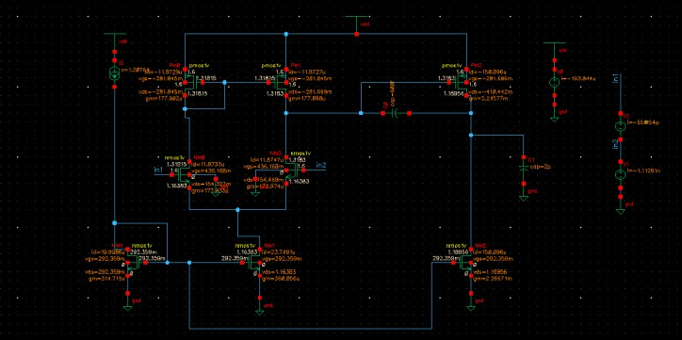
The obtained simulation results closely matched the theoretical calculations and design specifications.

RESULTS AND DISCUSSION
The proposed two-stage CMOS operational amplifier was designed and simulated using the Cadence Virtuoso simulation environment in CMOS technology. The performance of the operational amplifier was verified using DC analysis, AC analysis, transient analysis, and operating point analysis. The obtained simulation results were compared with the theoretical calculations to validate the proposed design methodology.

The operational amplifier was designed for a supply voltage of
1.2𝑉 with a load capacitance of 2𝑝𝐹 . Miller compensation technique was employed to improve stability and phase margin. The simulated results demonstrate that the designed operational amplifier satisfies the required gain, bandwidth, slew rate, and stability specifications

AC ANALYSIS
AC analysis was performed to determine the frequency response characteristics of the operational amplifier such as:
  - DC gain
  - Gain bandwidth product (GBW)
  - Phase margin
  - Stability
The AC response obtained from Cadence simulation shows that the proposed operational amplifier achieves an open-loop voltage gain of approximately:
56.15𝑑𝐵

The corresponding unity gain bandwidth obtained is:
35.34𝑀𝐻𝑧
The phase margin achieved from the simulation is approximately:

Fig. 2. Cadence Virtuoso schematic of the proposed two-stage CMOS op-amp.
59∘
The obtained phase margin confirms that the operational amplifier is stable under closed-loop operation. The use of Miller compensation effectively improved pole splitting and reduced instability due to higher-order poles. The gain bandwidth obtained is slightly higher than the target specification, which indicates improved frequency response performance.

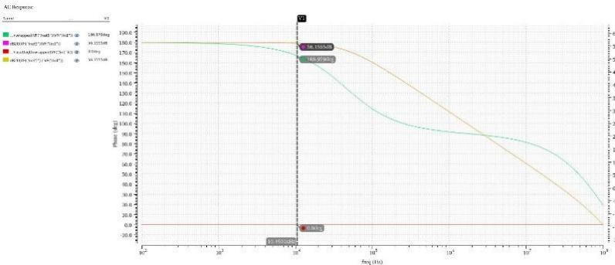
Fig. 3. AC response showing gain and phase margin.

Transient Analysis

Transient analysis was carried out to determine the large signal behavior and slew rate performance of the amplifier. A pulse input signal was applied and the output response was observed.

The slew rate of the amplifier is given by:

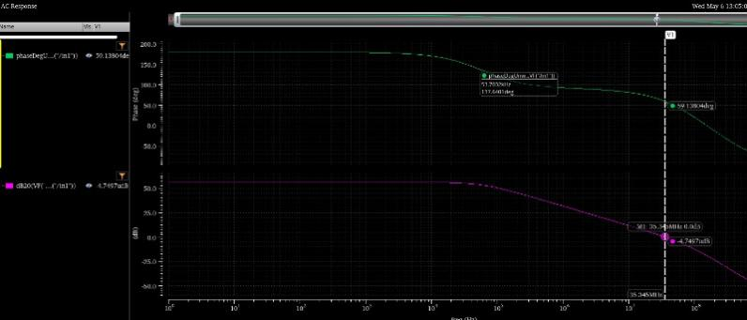
𝑆𝑅 =
𝑑𝑉𝑜

𝑑𝑡

The output waveform showed proper charging and discharging characteristics without distortion. The designed operational amplifier achieved a slew rate close to the required specification due to proper selection of bias current and compensation capacitor.

Fig. 4. AC response showing gain and phase margin.
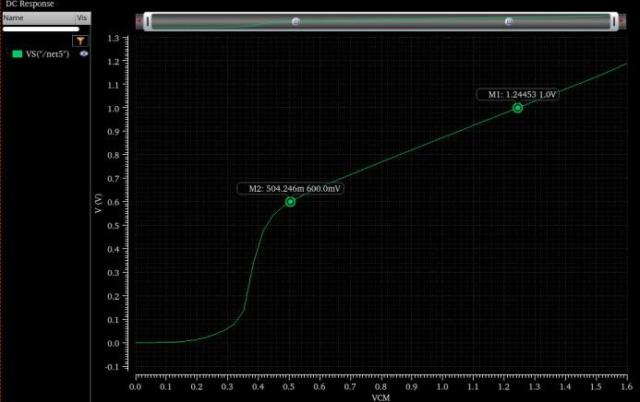
Fig. 5. ICMR (+) & ICMR(-)
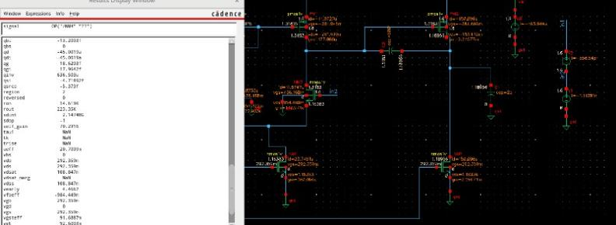
Fig. 6. State of each Transistor
The transient response also verified stable operation of the amplifier without oscillations or excessive overshoot.

DC Operating Point Analysis
DC operating point analysis was performed to verify the transconductance (𝑔𝑚), output conductance (𝑔𝑑𝑠), bias currents, and operating regions of MOS transistors.
The simulation results confirmed that all transistors operate in the saturation region, which is necessary for proper amplifier operation. The obtained transconductance values closely matched the theoretical calculations used for transistor sizing.
The DC operating point analysis also validated:
  - Proper current mirror operation
  - Stable bias current generation
  - Differential pair operation
  - Gain stage functionality

Gain Analysis
The total gain of the proposed operational amplifier was theoretically and practically verified using small signal analysis. The gain of the first stage and second stage together produced the required overall voltage gain.

The total gain obtained from simulation is approximately:

56.15𝑑𝐵

Theoretical calculations predicted gain values close to:
60𝑑𝐵 to 65𝑑𝐵

The slight variation between theoretical and simulated results is mainly due to:
  - Parasitic capacitances
  - Channel length modulation
  - Device non-idealities
  - Process parameter variations
However, the obtained gain is sufficiently close to the required specification and confirms proper design of the operational amplifier.

Stability Analysis
The stability of the operational amplifier mainly depends on phase margin and pole locations. Miller compensation capacitor 𝐶𝐶 was introduced to improve stability through pole splitting.
The obtained phase margin of approximately:
59∘

indicates stable operation of the amplifier. The compensation capacitor effectively shifted the dominant pole toward lower frequency and pushed the non-dominant pole toward higher frequency.
The amplifier showed:
  - Stable frequency response
  - Reduced oscillations
  - Improved transient performance
  - Proper closed-loop stability

DISCUSSION:
The simulation results clearly demonstrate that the proposed two-stage CMOS operational amplifier successfully achieves the required analog performance specifications. The use of Miller compensation significantly improved phase margin and overall stability of the circuit.
The theoretical calculations for transistor sizing, bias current, compensation capacitor, and gain analysis closely matched the Cadence simulation results.

The designed amplifier achieved:
  - High voltage gain
  - Good bandwidth
  - Stable operation
  - Improved slew rate performance
  - Proper frequency response
The small deviation between theoretical and simulated values is expected in practical CMOS analog circuit design because of second-order effects and parasitic parameters.
Overall, the proposed operational amplifier provides a good balance between gain, bandwidth, stability, and power consumption, making it suitable for low-voltage analog and mixed-signal integrated circuit applications.

Conclusion
In this project, a two-stage CMOS operational amplifier using Miller compensation technique was successfully designed and analyzed using Cadence Virtuoso simulation environment in CMOS technology. The operational amplifier was designed to achieve high voltage gain, sufficient bandwidth, good phase margin, and stable operation under low supply voltage conditions. The design methodology included theoretical calculations for transistor sizing, compensation capacitor selection, bias current calculation, and small signal gain analysis.
The proposed amplifier consists of a differential amplifier as the first stage and a common source amplifier as the second stage to obtain higher overall voltage gain. Miller compensation was employed to improve stability by pole splitting and to achieve proper phase margin. The theoretical calculations were validated through AC analysis, transient analysis, and DC operating point analysis.
The simulated results demonstrated an open-loop gain of approximately 56.15𝑑𝐵 , gain bandwidth product of 35.34𝑀𝐻𝑧, and phase margin close to 59∘, which are near the target design specifications. The transient analysis also confirmed satisfactory slew rate and stable output response without oscillations.
The designed operational amplifier achieved a good balance between gain, bandwidth, stability, and power consumption. The results confirm that the proposed two-stage CMOS op-amp is suitable for low-voltage analog and mixed-signal applications such as filters, data converters, sensor interfaces, and signal processing circuits.
Overall, the project provided a clear understanding of CMOS analog circuit design, Miller compensation techniques, frequency stability analysis, and practical implementation of operational amplifiers using Cadence Virtuoso environment.

. AcknowledgementS

The authors wish to thank the Department of Electronics and Communication Engineering, and management of Vasavi College of Engineering (A), Hyderabad, Telangana, India for granting access to the software tools used.

References
- P. Vimala, R. Dhirendra Rao, C. G. Gokhale, and A. V. S, “Design of Two Stage Miller Compensated CMOS Opamp with Nulling Resistor in 90nm Technology,” 2024 Third International Conference on Intelligent Techniques in Control, Optimization and Signal Processing (INCOS), 2024.
- B. Razavi, Design of Analog CMOS Integrated Circuits, New York, USA: McGraw-Hill Education, 2017.
- P. E. Allen and D. R. Holberg, CMOS Analog Circuit Design, 3rd ed., Oxford University Press, 2011.
- R. Jacob Baker, CMOS Circuit Design, Layout, and Simulation, 4th ed., Wiley-IEEE Press, 2019.
- A. S. Sedra and K. C. Smith, Microelectronic Circuits, 7th ed., Oxford University Press, 2015.
- C. L. Kavyashree, M. Hemambika, K. Dharani, A. V. Naik,
and M. P. Sunil, “Design and implementation of two stage CMOS operational amplifier using 90nm technology,” 2017 International Conference on Inventive Systems and Control (ICISC), Coimbatore, India, 2017.
- J. Mahattanakul and J. Chutichatuporn, “Design procedure for two-stage CMOS op-amp with flexible noise-power balancing scheme,” IEEE Transactions on Circuits and Systems I: Regular Papers, vol. 52, no. 8, pp. 1508–1514, 2005.
- Y. Guo, “An accurate design approach for two-stage CMOS operational amplifiers,” 2016 IEEE Asia Pacific Conference on Circuits and Systems (APCCAS), Jeju, South Korea, 2016.
- B. P. De, K. B. Maji, R. Kar, D. Mandal, and S. P. Ghoshal, “Application of improved PSO for optimal design of CMOS two-stage Op-amp using nulling resistor compensation circuit,” 2017 Devices for Integrated Circuit (DevIC), Kalyani, India, 2017.
- Boaz Shem-Tov, Mucahit Kozak, and Eby G. Friedman, “A High-Speed CMOS Op-Amp Design Technique using Negative Miller Capacitance,” Proceedings of the 11th IEEE International Conference on Electronics, Circuits and Systems, 2004.

